PUBLIC HEARING
Over Code Enforcement
June 16, 2026 @ 5:30 pm

Agenda

- Call to order
- Pledge of Allegiance
- Roll Call; Mayor Miller, Mayor Pro-Tem Rottino, Councilman Scoggins, Councilwoman Donaldson, Councilwoman Hanson and Councilwoman Cuevas.
- Discuss Code Enforcement w/City Attorney
Questions submitted before the meeting.
- Citizen Comments: Citizens wishing to speak must sign up to do so (3 Minute Maximum)

Close
- Next Regular Meeting 6/16/26 @ 6:30pm
- Adjourn

Approved

_
Andrea Miller - Mayor

_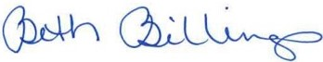_
Beth Billings – City Secretary

